2 Make Export Documents

Complete the booking of the work,，we will start on the export documents produced. Back to the master station, double-click the icon OutBound Doc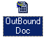, into the system module export documents.
First of all popup as shown in figure 2-19 window, we close the window. (note: this window is used to search has made export documents data but also changed the booking data record, because in real business, modify the data is often, even after shipment, modify data is also appear. The students don't need to the system the function of other understand.
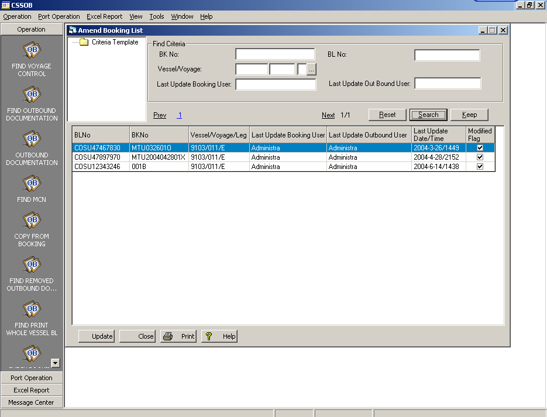
Figure 2 - 19
2.1 COPY BOOKING data COPY FROM BOOKING, generating basic export documents data
The first step to the front of the input booking data copy out, generate the corresponding export documents of the basic data.
Click the left button, pop-up figure 2 -20, in the Initial User input your student id (i.e. your login User name, you can also enter the Booking Number in front of a record Number to BK No fields to search), and then click the right button interface, the system will list all Initial User input get Booking confirmation of the material. If the 【Link】 column has the sign of hook, said Booking have data copy generated the export documents, no hook that has not yet been copy generated export documents of Booking data.

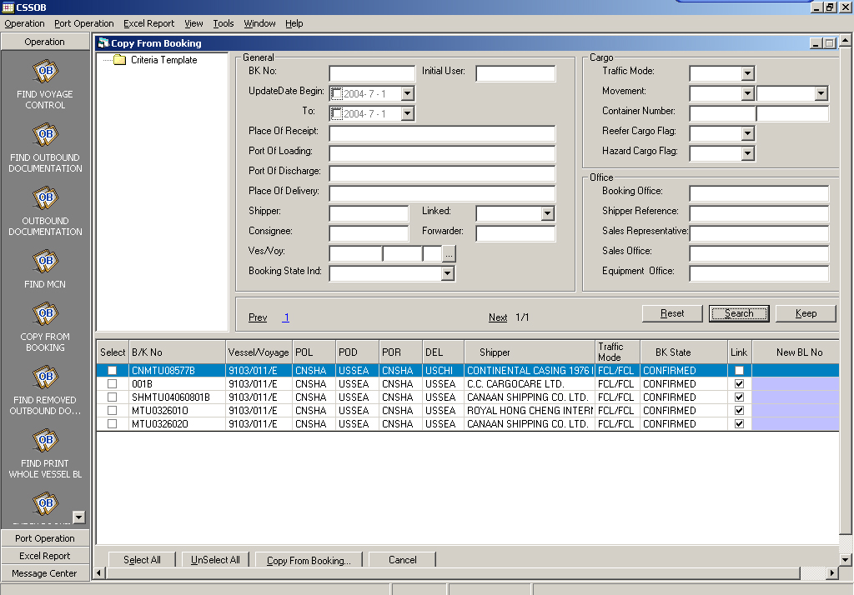
Figure 2-20
To you just do the 【Link】column has not tick the booking data, in the【Select】 column a hook, and then click, the system will appear a booking material copy to the success of OB confirmation dialog, as shown in figure 2-21.
There are automatically generated bill of lading number, use the pen to record the bill of lading number, it will be used behind .
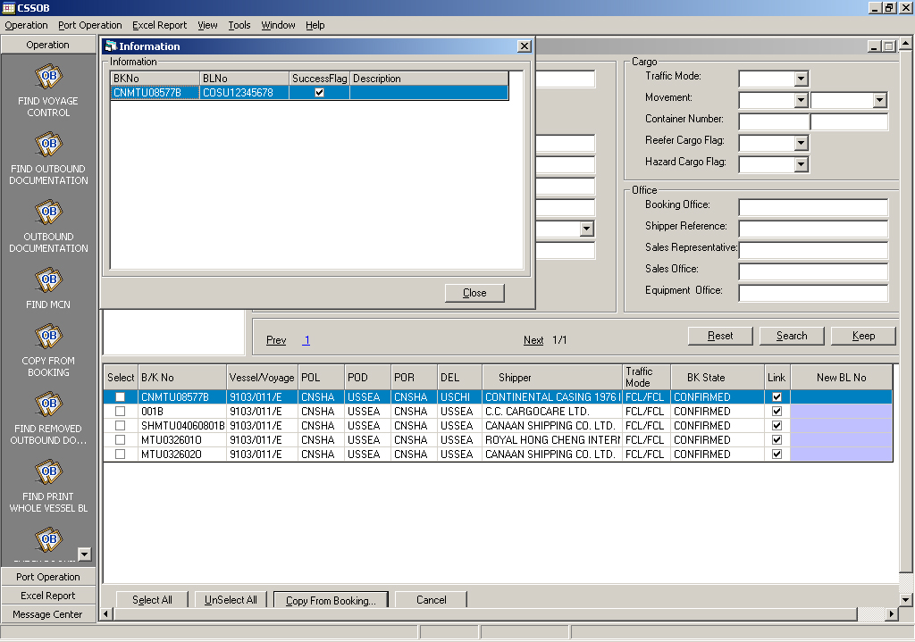
Figure 2-21

Confirmation, can close copy window.
2.2 added export documents data
2.2.1 find has a copy of the export documents
Click on the button on the left side of the screen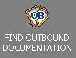, in the pop-up window of the above BL No field input just record of the bill of lading number (or, also can be in the right BK No field input previously recorded booking number), and click on the button, the system will list all have copy generated export documents, as shown in figure 2 -20. At the same time, here also lists the documents of the editor.
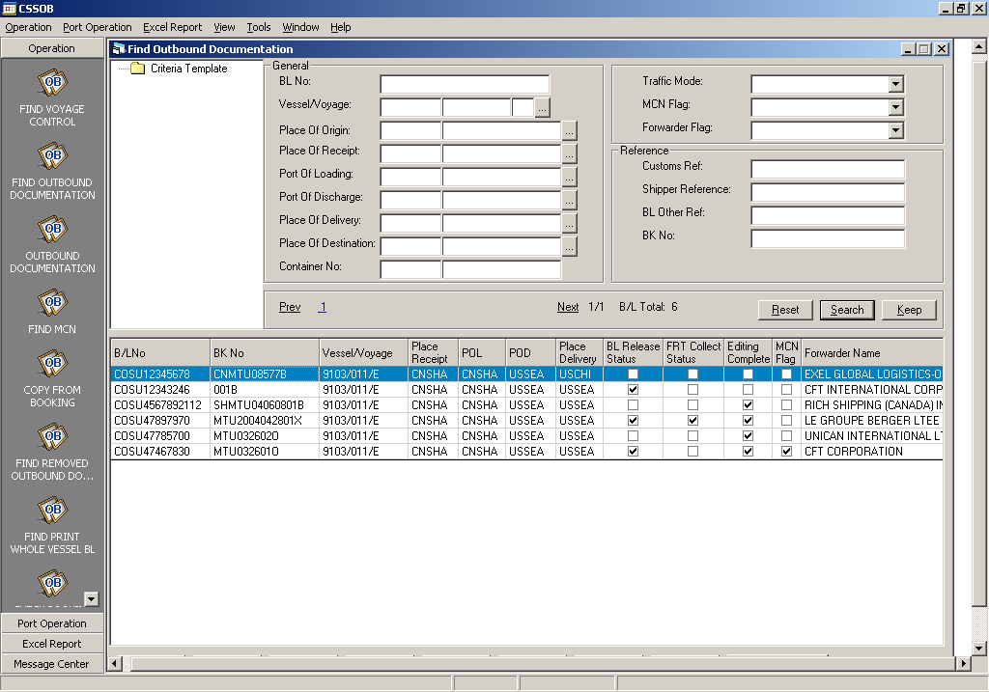
Figure 2 - 20
Double click the selected a document records, into the document editing interface, as shown in figure 2-21. Here, you just add the necessary documents data.

2.2.2 General page
Issue Place (bill of lading Issue at) : click, in the pop-up dialog of the【Code】type "CNSHA" (Shanghai), and then click, click on the selected;
At the same time also must input Export license number, that is the 【Proof of Export】. The input number is must be less than five figures, otherwise will make mistakes, such as 1236.
There are other data, such as BL Type choose 0 (says it will issue Original b/l), No of Original (Original b/l number)(3), No of Copies (copy of b/l number)(7), Issue Place(CNSHA ,Shanghai)and then click save.
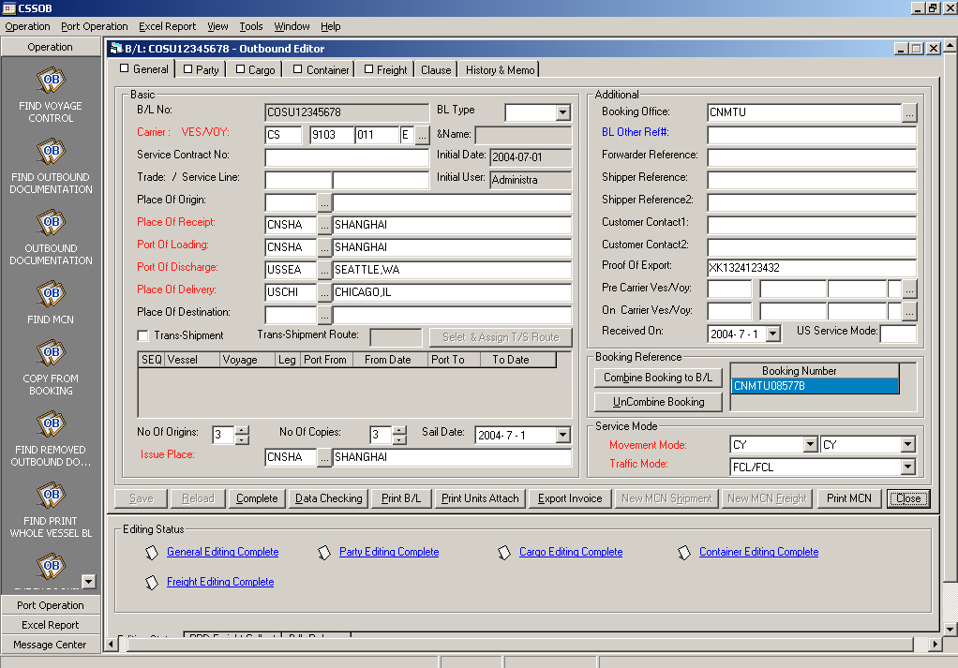
Figure 2-21

2.2.3 Party page

In the Party page, must be input Notify1 data [you can literally a a customer data. But in real business, it is the customer will tell you is that notice people.] , (if the booking didn't lose Consignee information, and here also need to be added to the input), here we all choose "American electronic".

2.2.4 Container page

Click on the right of Link Cargo ... Button, select the goods on the link.Fill the frame according the booking.And 【traffic】select ‘FCL/FCL’.【Description】input “general cargoes”.

2.2.5 test data and complete input

Preliminary inspection data, you can click on the button, the system to check data, the system prompt check through, (if container number are error,click ignore options) and progressive into Generel, Party, Cargo, Container, Freight page, click, the system first tip is sure if you want to top complete mark, because after top, data cannot be modified. In the prompt dialog click on the confirmation, the system hint to identify successful, the system will lock data.

2.2.6 The issue of bills of lading

The ship sailed, they can issue the bill of lading.
In the bottom of the interface, select the B/L Release, as shown in figure 2-23.
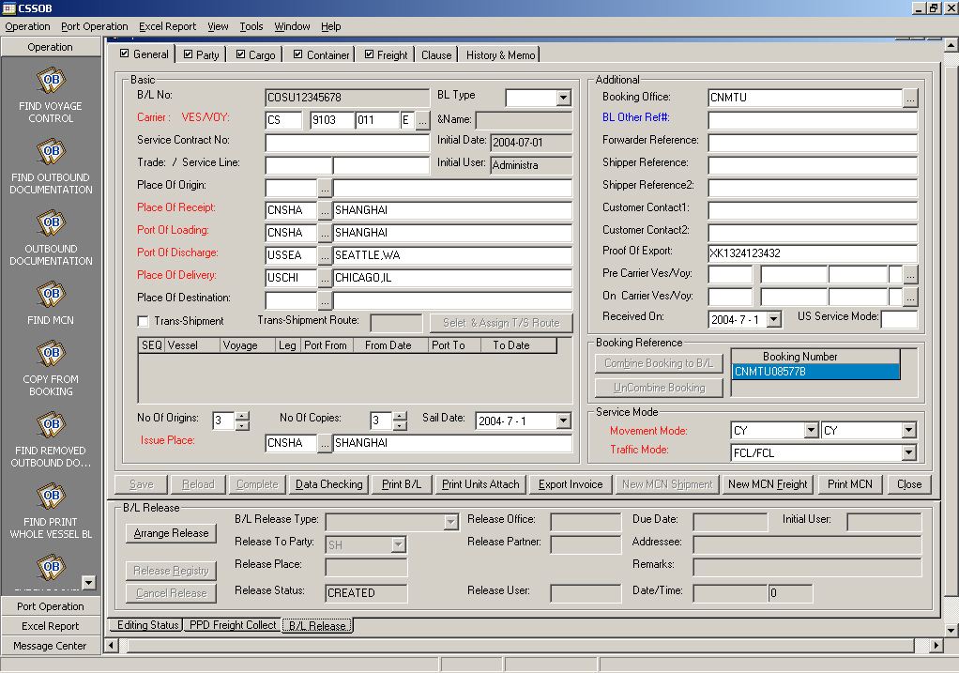
Figure 2-23
Click, the system pop-up a bill of lading issued by the edit box, as shown in figure 2-24.
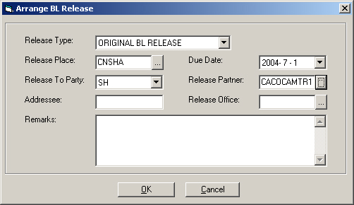
Figure 2-24

Fill in the【Release Type】issue ORIGINAL BLRELEASE Type, 【Release Place】 issue at CNSHA, Release TO PARTY for SH shipper, Ralease Office for CNSMU (Shanghai Office),【due date】is the date that the ship departed the port and other data, click on the confirmation after input. At that time the system will appear a warning box, as shown in figure 2-25, indicating that the customer is not the freight settlement, confirm whether to arrange the issue of bills of lading. The bill of lading as a document of title, it is very important legal documents. Please click and confirm to the issue of bills of lading.
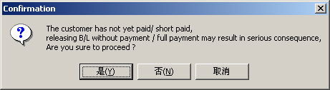
Figure 2-25

At that time, at the bottom of the interface the【Release Status】display as "CREATED", and click the Release of the documents. In the pop-up interface in the bill of lading issued by input the【 Release Office】, same click "OK" button, the same in the system of the pop-up warning dialog box, click on "force", at that time, the 【Release Status】display as "RELEASED".
Then the export manifest, and bill of lading are issued, the export documents work is completed.
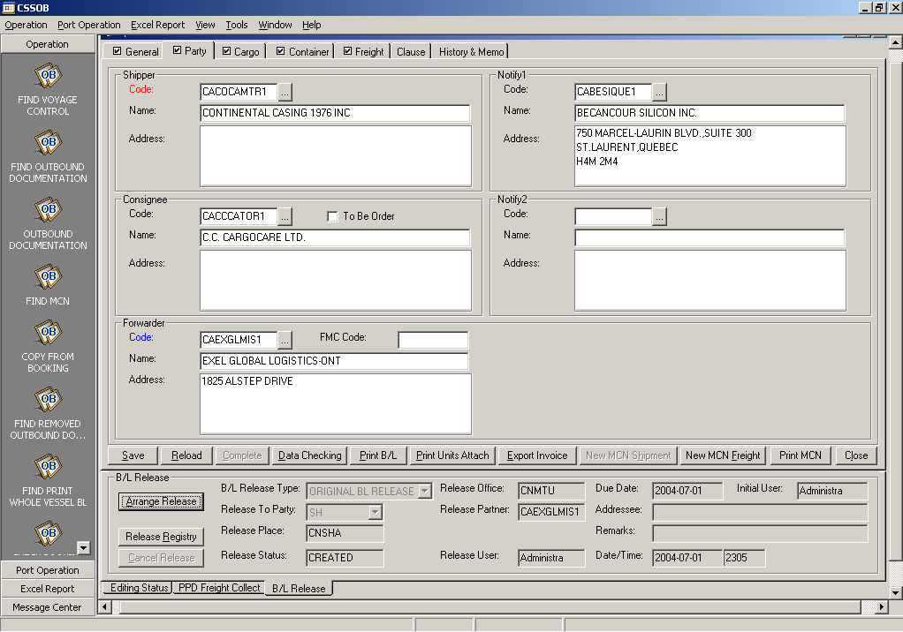
Figure 2 - 26

3 should be collection processing

(AR/AP modules, namely processing accounts Receivable sea freight operation, AR Account Receivable is should be collection, AP is Account Payable accounts Payable)
Now, because of in this case, the sea freight prepaid form(set in Booking module Freight page), so the loading port Office after ship open, it should be processed the sea Freight of account receivable, the basic process is that the system generated invoice at first, and then canceled after verification the invoice after received customer Freight .
Back to the master station, and then double-click AR/AP icon, into the receipt and payment system management module.

3.1 looking for to make invoice export documents

Click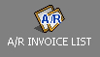, click in the pop-up interface interface right button, the system will list all have input cost record, including the cost of the invoice has been generated record and not generating invoices, as shown in figure 2-34. List, through the 【Process Status】 this column can judge whether the cost has generated the invoice. If shown as "DRAFT", it is also not generate invoice, shown as "A/R CREATED" is already generated the invoice.

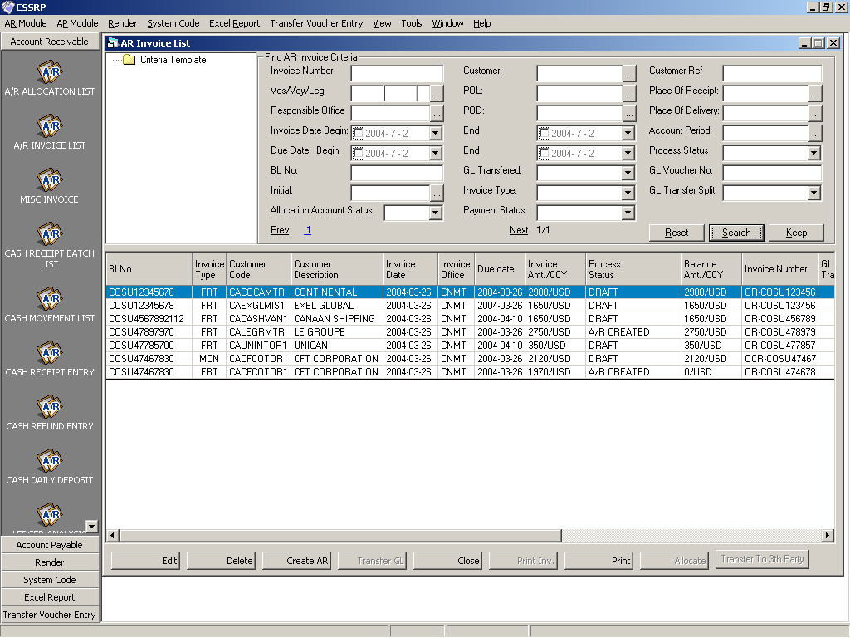
Figure 2 - 34

On the top of the interface there is BL No field in the condition area, enter your record in the bill of lading number of the previous class, and click on the button , in the search results you should choose a record to generate invoice , then click, pop-up a confirmation dialog box, input the date invoice data is ‘the delivery day’,the due data is ‘the arrival day’ . as shown in figure 2-35, and then click on the confirmation, the system pop-up a invoice generate confirmation dialog, click . At this time, the list corresponding record "Process Status" will display as "A/R CREATED".
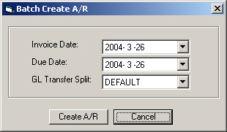
Figure 2-35

Double click the selected cost record, can view the invoice of detailed information, or other further information editing, as shown in figure 2-36.
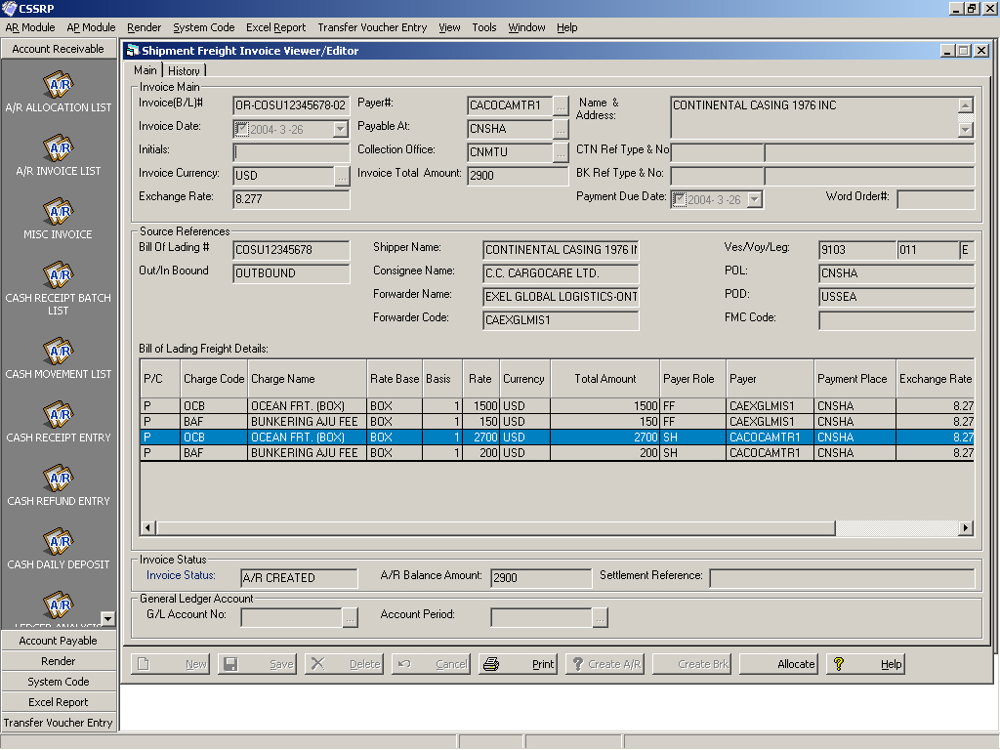
Figure 2-36
3.2 record collection

When the shipper received customer's money, he should record first.
Click ,click the button on the right of pop-up interface , the system will list all inputted collection record . Click into collection editing interface, generating a new collection records, as shown in figure 2-37. Input the corresponding data, including the【Cheque Number】(check Number, input CK and serial Number, such as ck001, ck002), the【Cheque date】 is ‘the arrival day’. the【weekend date】is ‘the next month of arrival day’.the【Payer Code】(payer)(code:CANGJIA), the 【Cheque Amount】 (Cheque Amount)(27000*6.233), 【Deposit Bank Acc.】(payment account)(hsbc-usd)【office】(CNSMU), etc. And then click save. Confirm data and correct, click, locking data.
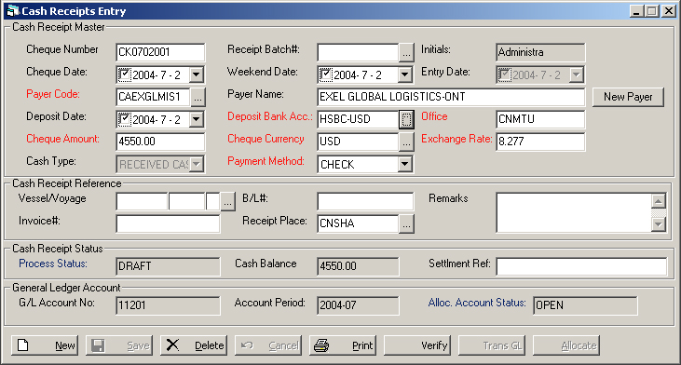
Figure 2 - 37

3.3 receivables cancel after verification

Now, the received money should allocate to the corresponding invoice, to cancel after verification the invoice
In figure 2 - 37 collection recording interface, click into account receivable cancel after verification interface, as shown in figure 2 -38. In the first half of the interface of "Cash Receipt" shows the received freight record information. Click, in terms of the popup interface the Invoice (B/L) # field, enter the number of the bill of lading or front record Invoice number, click, in the list of alternative Invoice choose to cancel after verification of the Invoice, as shown in figure 2-39, click, the system will be selected Invoice information listed in the cancel after verification interface, as shown in figure 2 -40.
Then click, then click on the distribution button, pop-up dialog box select confirmation, then the system will pop up that cancel after verification have been success.
Attention, distribution, the Balance of the invoice is Balance Amount (not Balance Amt after Allocating) should be 0,means cancel after verification is over. If not equal to zero, then the money is not enough, you need to create a new collection record and distribution to the invoice, until the cancel after verification is over.
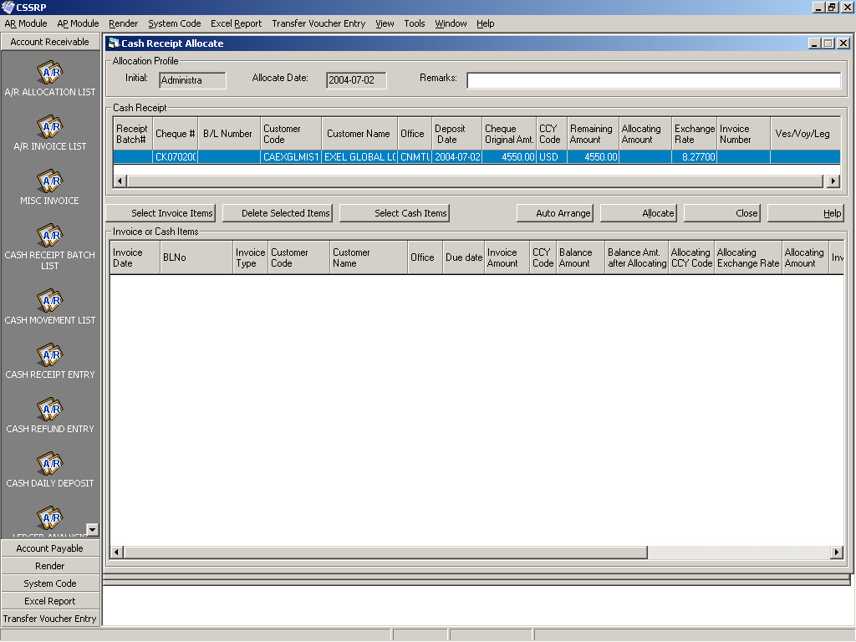
Figure 2 - 38
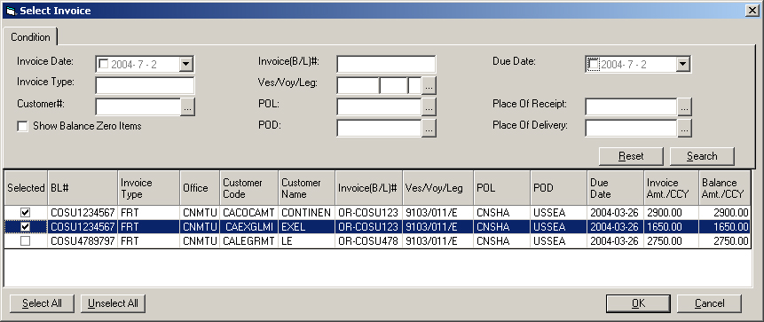
Figure 2 -39
