Liner transport management system（1st class)
Flow Chart
Received Forwarder booking
( Send by forwarder )

Input booking information: 1,Added the new booking data input booking basic information.2,Input Cargo information 3,Input the box quantities requesting from booking 4,Input confirmed sea freight
After that then save, if not given booking number, the system will automatically generate booking number (billing of landing no.).
Click on the Validate Booking, check Booking data is correct; Click Confirm Booking button, Confirm Booking data (After confirmation, the data will not be able to change), and then you can carry out follow-up manifest editor, bill of lading production
sailing schedule

Input the container number,seal number into the system to confirm already picked up the container.

Accept booking
Seal the confirm chapter on the fifth form of booking form to confirm with booking, keep back the 2nd, 3rd, 4th form, and the rest forms return to freight forwarder and inform the bill of lading number
Receive the dynamic container report from yard to confirmed that have picked up the container
Export booking
Extraction booking data (COPY), and according to the ten form (booking)complete the data integrity(mainly is the SHIPPER, CONSIGNEE, NOTIFY PARTY information), forming manifest

In each of the OB module interface page, click on Complete confirmation, Complete manifest and then manifest data cannot be changed
After the ship leave port, click Arrange Release, fill in the corresponding data to show can issue the bill of lading (if system judgment prepaid manifest freight not received, it will pop up an alert, rectification by artificial judgment whether to continue the issue of bills of lading)

Click on the Release Registry confirmation issued

Generate financial invoice
Input paid in original documents
Cancel after verification
actual freight to receivable freight
issue a bill of lading

Export manifest bill of lading
Cost data move to the financial system, carry on financial processing
After the ship leaved port, and it arrived at the discharge port (hereinafter operation is shipping company in the port of discharge branch operation)

Receive import manifest data (by fax or EDI)

Establish import voyage (prior already exists, don't input, actual should by managers input, not by the students input)

Maintenance import manifest data

In the IB module of each interface page, click on Complete confirmation, Complete import manifest and then manifest data cannot be changed

import operation

Cost data move to the financial system, carry on financial processing

Generate financial invoice

After the goods arrived
Input paid in original documents
When the ship leaved port, click Arrange Release, fill in the corresponding data, to show that can put the goods (if system judgment to collect manifest freight not received, it will pop up an alert, rectification by artificial judgment whether release cargo)

Cancel after verification
actual freight to receivable freight

Send the arrival notice to the consignee

Release cargo information registration (by the consignee with customs clearance chapter of bill of lading (commonly known as small bill of lading) pick up the goods)

Note:
（1）If software operation have mistakes or anomaly, you can see at the end of the text there is common problem solving.

A. System Background
Liner companies in each port has its own Office (Office), dealing with the port in business documents. Liner company headquarters subordinate relationship between each port office as shown in the figure. The figure presents one line on A, B, C, D the four respective port office.
The whole information system including database are installed in the headquarters, the office through the Citrix (terminal service mode) landing to headquarters, for his part of the operation, so it is the centralized system.

Head office

A B C D

B. The Description Of Experiment
The experiment to simulate the operation of the two offices, assuming that one ship belong to the liner company need to set sail from Shanghai (code: CNSHA) to Seattle port (code: USSEA).
So our simulation is located in Shanghai Port's Shanghai office (code: CNSMU) export documents operation business, then simulate the port of Seattle Seattle office (code: USSEA) import documents operation business. As shown in figure.

Character1:Shanghai office document operator
Operation:Shanghai export documents operation
Character 2: Seattle port office document operator
Operation: port of Seattle import documents operation
export

import

Here we clear a few code again:
Shanghai code: CNSHA
Liner company Shanghai Office (Booking Office) code: CNSMU

Seattle port code: USSEA
Liner companies Seattle Office (Booking Office) code: USSEA

C.The Case
Assume that a shipper "Shanghai konka" want to ship a container of cargo from Shanghai port, discharge to the port of Seattle, freight prepaid form (not to collect form, of course, then the students can practice to collect form of treatment). The business entrusted to COSCO shipping company.
We want to simulate the consignment for business from the export to imported liner company office all documents operation.

The name of the carrying vessel voyage is: CS 9103 011 E (among them, CS is the carrier that liner company name, here is the abbreviation of cosco, 9103 is a ship's code, the actual name for CSCL SHANGHAI; 011 is route code, E is a suffix, represents the eastward).
The customer wants to Shanghai from the XX2 box area take empty box, pack full goods to the heavy box to return to Shanghai XX1 box area waiting for shipping.
Involved in the business of the relevant personnel mechanism is as follows:
The Shipper (Shipper) : Shanghai konka (code: CANGJIA, name: Shanghai konka)
Freight forwarders (Forwarder) : Shanghai sea lion forwarding ）
Company (code: SHMTU, name: Shanghai sea lion forwarding company)
The Consignee (Consignee) : American electronics (code: USDZ, name: the electronic)
POR (Place of Receipt) : Place of Receipt CNSHA, i.e., Shanghai
POD (Place of Discharge): USSEA
Delivery: delivery to USSEA, namely, the port of Seattle
POR TIME：TODAY
POL ETD：TOMORROW
POD EDA：NEXT MONTH
DEL EDA:NEXT DAY OF POD EDA

Shanghai code: CNSHA
Liner company Shanghai Office (Booking Office) code: CNSMU

Seattle port code: USSEA
Liner companies Seattle office code: USSEA

No of Packages (number)(1), Package Type (packaging, select input)(CONTAINER), PKG Description (packaging), Gross Weight (Gross Weight)(25), Net Weight( Net Weight)(20), Weight Nuit (Unit of Weight, select input)(KGS), Gross Cube (volume)(40), Net Cube (Net volume)(35), Cube Unit (volume Unit, select input)(CBM). Marks&No: (marks, here input NA), Cargo Description (Cargo Description). Comm. Group and Commodity (name of Commodity and organization)(search:description:television cameras,color)

If it is frozen goods, selected the 【Reefer】 in front of the marquee, the activation Temperature (Temperature Settings), Min (minimum Temperature), Max (the highest Temperature). If it is long overweight goods, selected the 【OOG】 in front of the marquee. If it is dangerous goods, select the【Hazard】 in front of the marquee, activate the input area "Hazard" page
input the detailed information of application container (40FR，1，SOC，25，40，1，CNT，XX2，TODAY，XX1，POL ETD）, here explain several major projects: SOC (shipper own container), Empty Pickup Terminal/Name (Pick up the empty container stockpiling area code and place name, here choose xx2), Full Return Terminal/Name (Return to the heavy box stockpiling area code and place Name), the location of returning the heavy container generally is the same with Generel page’s POL/Terminal, namely xx1.
(Notice, container number and seal sign number can input two Numbers in optional, if it pop-up the error prompt choice when you save,you can forced to save. Seal NO. 166372 can be input.
input the detailed freight（40FR，P，BAF，1，27000，6.233)

D. Experimental Procedure
The business of the whole operation process required four steps are shown below.

The operation of the Shanghai office | The operation of the Seattle office
1 export order made manifest  (Booking module, namely accept customers Booking) | 4 import documents making  (InBound Doc module, according to export documents making import documents after the ship arrive the port)
2 make export documents
(OutBound Doc module, according to booking documents making export documents)
3 account receivable processing
(AR/AP modules, namely processing accounts receivable sea freight operation)

The four steps is in turn, each step and divided into several small steps. Below, we according to the following list of the detailed steps to operate.
Note:
(1) Software operation mistakes and anomaly, see at the end of this common problem solving
1 export Booking production: Booking module, namely accept customers Booking
First of all, start liner system, into the main console interface as follows:

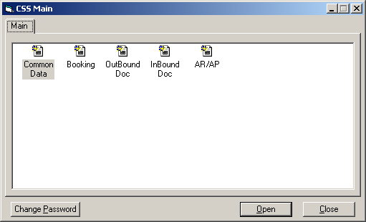

Double click the icon Booking to enter the system of Booking module, as the chart
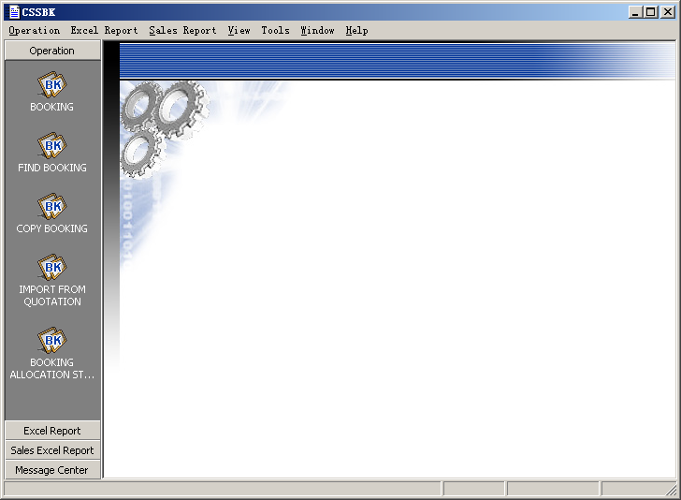

1.1 General page
Click the left side button BOOKING, into the new added manifest interface, as shown in figure 2-3. The first is in General page, interface displayed in red position, is must input data.
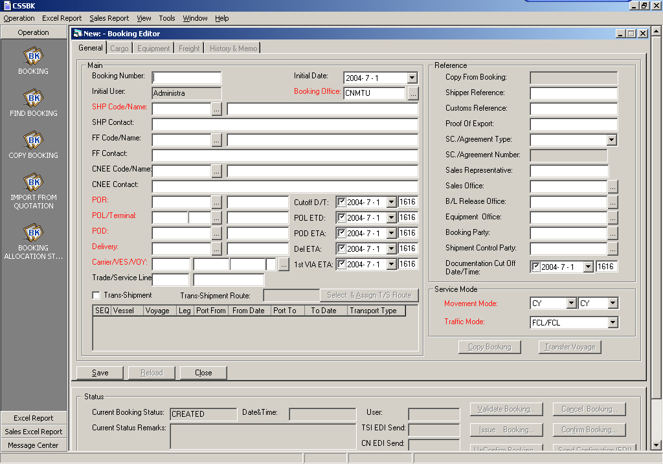
Figure 2-3
According to our given case, input the corresponding data. Notice, figure 2-3 the right side Reference area don't input.
When you Input data maybe there are some data can't remember, you can search input, don't need to directly input. Such as if you want to input SHP Code/Name, click the edit box that follow the back button , pop-up a search dialog box (as shown in figure 2-4), In the Partner Code input SHIPPER Code, or in the Parnter Name input in the Name of the SHIPPER, and click on the button , the system will display accessing to customer data in the middle of the display window, because of the system has the function of fuzzy query, probably in optional display frame appeared in more than one customer information, the user can select by yourself, click the button , the system will exit the interface, and automatic fill the data into the chart 2-3 booking editing interface (if not input any search criteria, directly click on the search button, can search out all Partner, click the Reset button can clear all conditions).

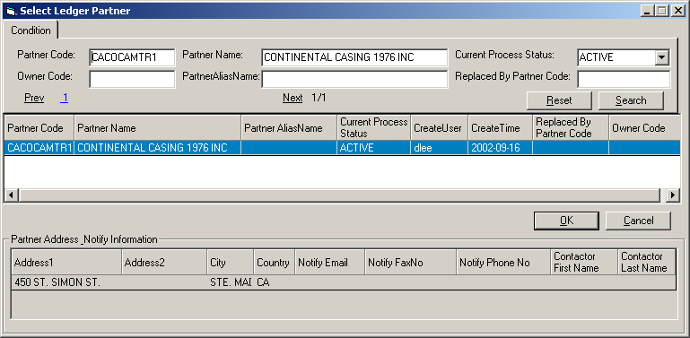
Figure 2-4

Input the FF Code/Name and CNEE Code/Name as well.
When you input the POR (Place of Receipt: Place of Receipt),you can also click the button on the back of edit box, the system pop-up SELECT PORT editing interface (as shown in figure 2-5), Input PORT Standard Five Word Code in the Code frame, here we assume that the Place of Receipt and the PORT of Loading is the same Shanghai CNSHA, and click on the button , the system will display queries to the port in the middle of the display window,after selecting click the button , the system will exit the interface, and fill the data into the figure 2-3 booking editing interface, input POD (PORT of DISCHARGE), Delivery as well.

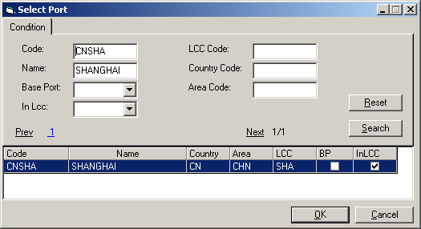
Figure 2-5
But when you input the POL/Terminal (loading port container depot area, namely box area), it is a little has changed. First of all here should explain the meaning of the Terminal. In fact, we all know, in a port there has multiple container depot area, the meaning of the Terminal is refers to the port stockpiling area, so click the button back of POL/Terminal edit box , the interface which pop-up is different from other port pop-up interface , as shown in figure 2-6. Input the Shanghai Code CNSHA into the Place Code, click the button, it will display many data in the alternative frame, but each data’s Depot Code is different, the Depot Code is the code of port container depot area . The regional information in real business is very important, if wrong, is likely to lead to when the customs inspection, even in the last shipment time can't find container, which could not smooth shipment, appear leaks installs the and so on. Here, we can choose xx1 box area, as a simulation.
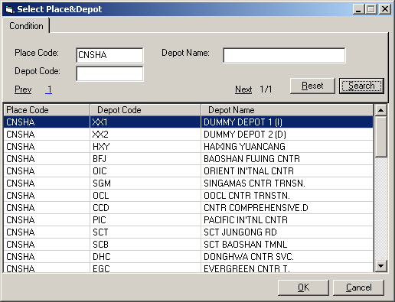
Figure 2-6
The next step is to input the name of Vessel, is also to click on the button, pop-up Vessel/Voyage edit box as shown in figure 2-7, input the Vessel name code in Vessel frame: 9103, and then click, in the list of alternative voyage choose a voyage, and click ok.
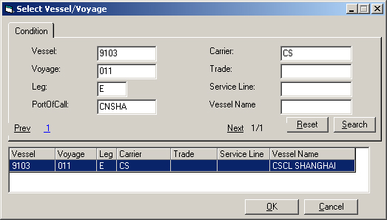
Figure 2-7
As for the right side of the interface the【Movement Mode】, this is the clause of receiving,delivery place, it can have a lot of ways, 【Traffic Mode】, is receiving, delivery terms clause, in general the ship company use the "FCL/FCL" clause, the full container receiving, the full container delivery.
Input all kinds of date information, Notice the relationship during the date.
The necessary input is finished, click save, i.e., as shown in figure 2-8 shows the editing interface. Save time, the system will automatically generate a Booking Number, as shown in the top right corner to edit interface, with a pen to record the Number, behind to use.
(note: when saving a warning if the popup window, click the Force Acceptance button) 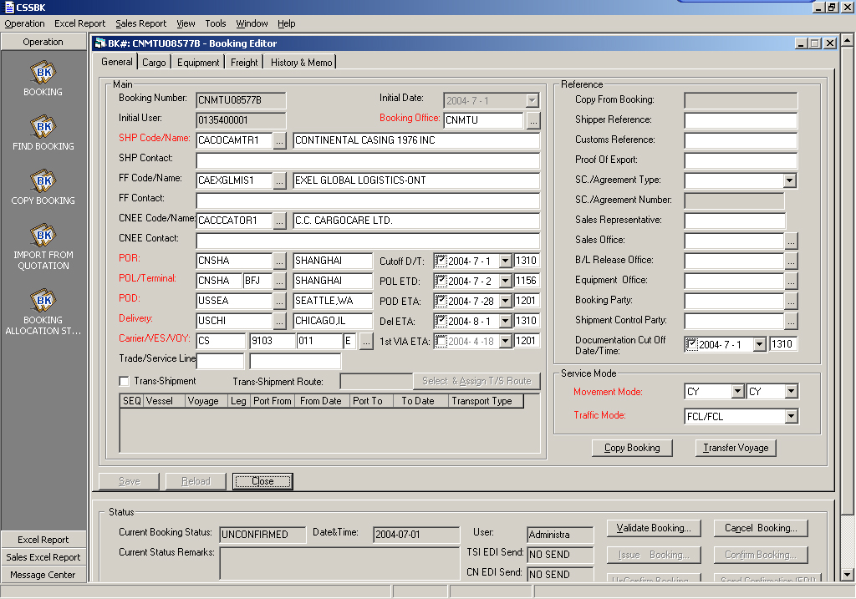
Figure 2-8

1.2 Cargo page
Then, input cargo information. Switch to Cargo page (as shown in figure 2-9).
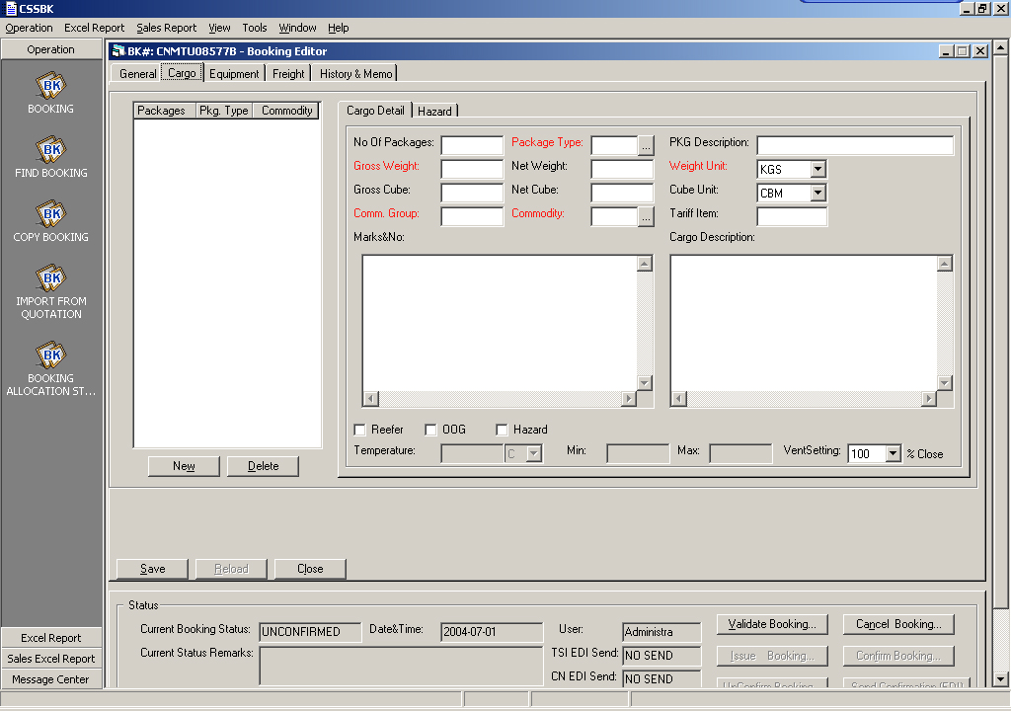
Figure 2-9
Click, added new goods records, input No of Packages (number)(1), Package Type (packaging, select input)(CONTAINER), PKG Description (packaging), Gross Weight (Gross Weight)(25), Net Weight( Net Weight)(20), Weight Unit (Unit of Weight, select input)(KGS), Gross Cube (volume)(40), Net Cube (Net volume)(35), Cube Unit (volume Unit, select input)(CBM). Marks&No: (marks, here input NA), Cargo Description (Cargo Description).
Here need to notice how input into the Comm. Group and Commodity (name of Commodity and organization), you can click on the button next to Commodity the... Search input. (search:description:television cameras,color)
If it is frozen goods, selected the 【Reefer】 in front of the check box, to activate the Temperature (Temperature Settings), Min (the lowest Temperature), Max (the highest Temperature). If it is overlength overweight goods, selected the 【OOG】 in front of the check box. If it is dangerous goods, select the【Hazard】 in front of the check box, activate the input area "Hazard" page (as shown in figure 2-10). Input after click save. (if you want to add another cargo,please click the button【New】again)
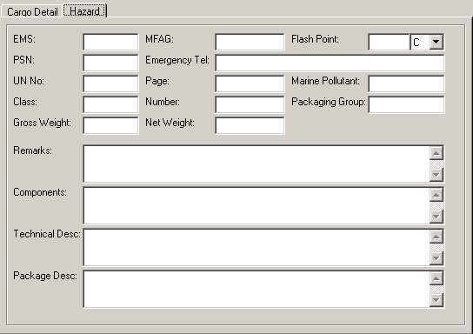
Figure 2-10
1.3 Equipment Page
Then, to input container information. Switch to Equipment page (as shown in figure 2-11).

1.3.1 input the information of application container

Interface is divided into above and bottom two area, input into the above areas is when freight forwarding booking the application for container quantity, at this time we are not know CONTAINER No. The below areas displays the actual picked up container number.
Now first of all we do the above area inputting , click on the , input the detailed information of application container (40FR，1，SOC，25，40，1，CNT，XX2，TODAY，XX1，POL ETD）, here explain several major projects: SOC (shipper own container), Empty Pickup Terminal/Name (Pick up the empty container stockpiling area code and place name, here choose xx2), Full Return Terminal/Name (Return to the heavy box stockpiling area code and place Name), the location of returning the heavy container generally is the same with Generel page’s POL/Terminal, namely xx1. After input completely, click on the save.
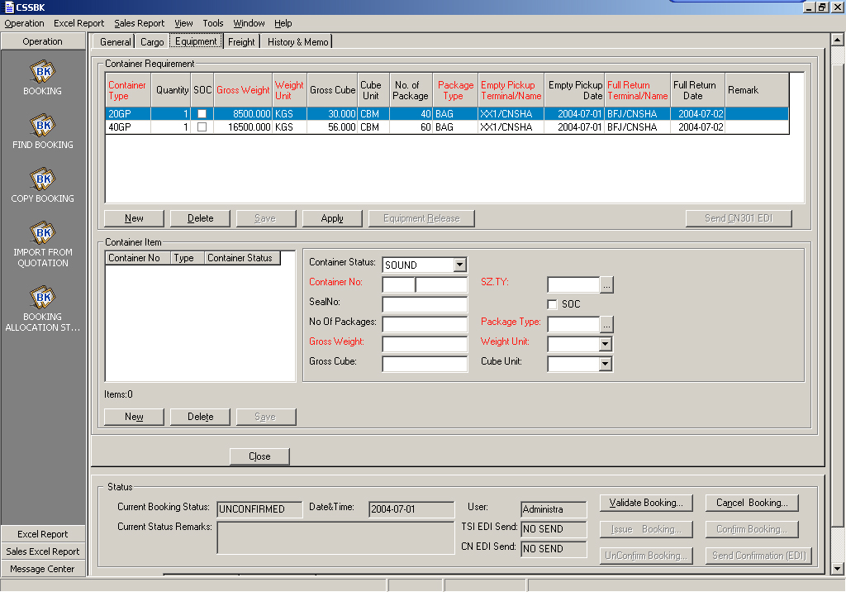
Area A
Area B
Figure 2-11
Notice the cargo weight, volume of Cargo pages is consistent with the cargo weight, volume of Equipment page, otherwise there will be error, and it is easy to get wrong place.

1.3.2 input the actual container information: confirmed container number and seal sign number.
Later,if you received the confirmation from yard, forwarder had returned the heavy container, at this time you can know the exact container number and seal sign number. At this time, you should register the information to the lower area of the Equipment page.
In the Equipment page, click on the middle of the interface button, in the pop-up asking box, click ,in figure 2-11 the right side of area B, input the correctly container number and seal sign number, click the save, as shown in figure 2-16. (Notice, container number and seal sign number can input two Numbers in optional, if it pop-up the error prompt choice when you save,you can forced to save. Seal NO. 166372 can be input.
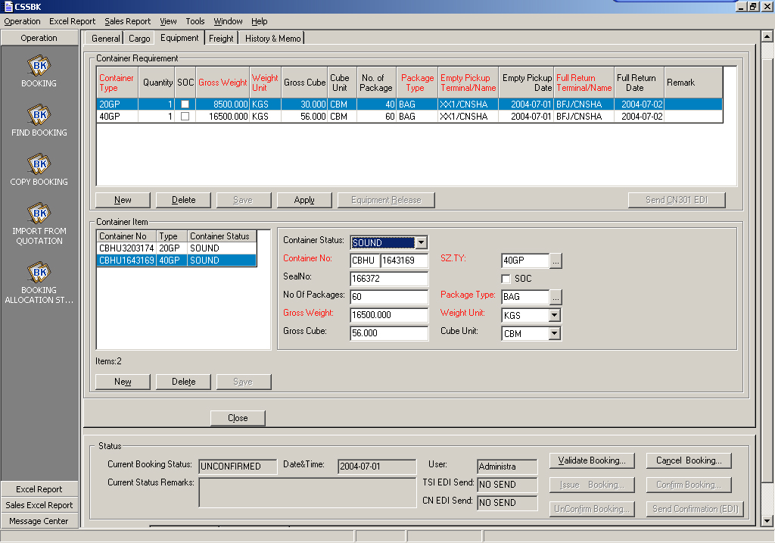
Figure 2-16

1.4 Freight page
Then, input confirmed freight information. Switch to Freight page (as shown in figure 2-12).
Click on the central of the interface , input the detailed freight（40FR，P，BAF，1，27000，6.233) and then click save. Generally the ship company will return to booking agency a percentage of commission, you can input data into the interface of commission registration .
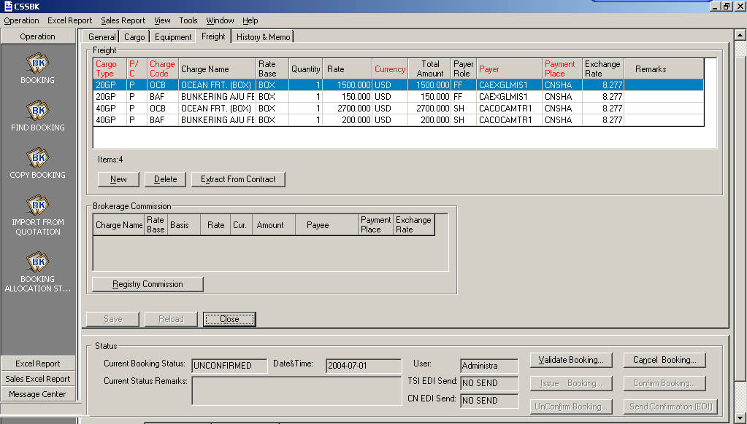
Figure 2 -12

Click on the button, pop up a dialog box, as shown in figure 2-13. Here we choose top one, then in this interface we switch to the【Entry】page, the system according to the previous defined scale return the commission back to forwarder, as shown in figure 2-14, click save then you will return back to the Freight page. And then click the bottom left.
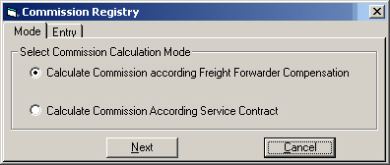
Figure 2-13
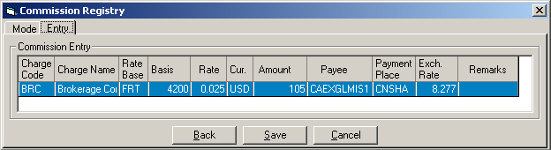
Figure 2-14

1.5 History and Memo page
And in the History and Memo page, there are records operating by system record operators, they can not be edited, you can only check the data (as shown in figure 2-15).
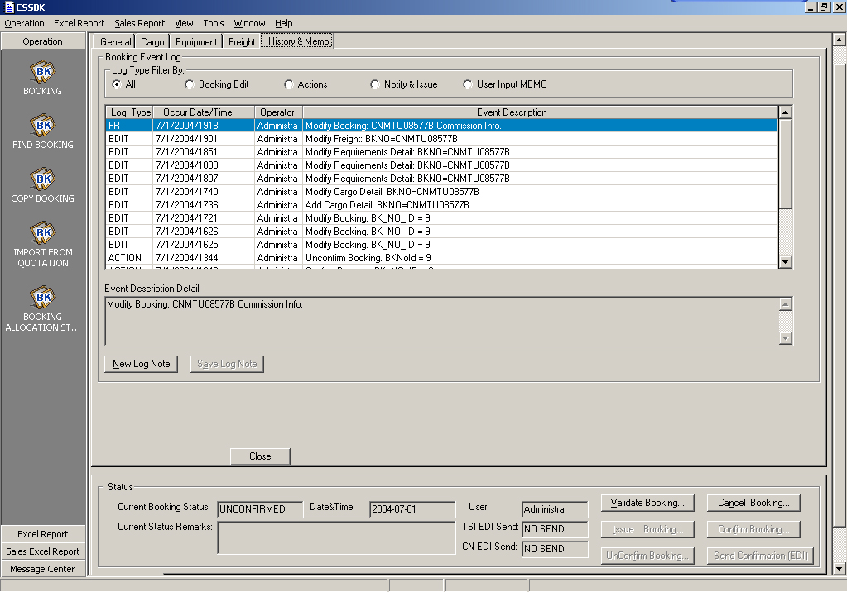
Figure 2-15
So far, all of the booking data has been basically complete input, and then we need to confirm these data.

1.7 logic check
In the booking data there are some data with logical consistency, you need to check whether the data you input into are truthfulness, these data are:
(1) Some dates in the General pages have logical relationship.(before or after)
(2) Two date in the Equipment page have logical relationship with the POL ETD of Gereral pages.
(3) the POL/Terminal of Gereral pages is consistent with the Full Return Terminal/Name of Equipment page.
(4) the Cargo weight, volume of Cargo pages is consistent with the Cargo weight, volume of Equipment page.
If the above data inconsistency, please to make a booking.

1.6 Booking data Confirm that Validate Booking and Confirm Booking
Upon confirmation of data integrity, in the system need to confirm. In any interface, you can click on the interface below "Status" area, a dialog box system, click YES,then jump a dialog box as shown in figure 2-18, click, make sure all the booking information, the system returned to the main interface, and then click ok. This button click, Booking of all data cannot be changed. In this way, can complete the booking work.
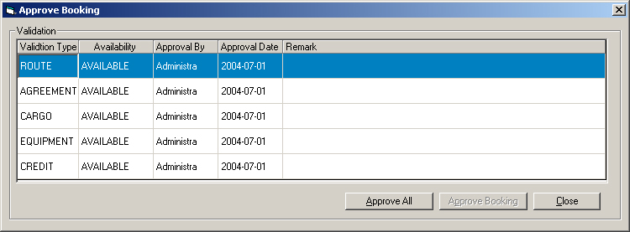
Figure 2 - 18

